Blackwing Implementation Architecture & SRE Handbook (BW-RFC-016 - 025)

Document Version: 1.0.0 | Status: Approved (Architecture Baseline)

Editors: Principal Systems Engineering, SRE, & Platform Hardening Groups

1. Supplementary RFC Specifications
This section codifies the additional system design standards required for robust multi-GPU, clustered, and policy-governed production rollouts.

BW-RFC-016: Session Resumption & Connection Migration
- QUIC Connection Migration: When an active interface swap occurs (e.g., Wi-Fi to cellular), the Console transmits a non-probing frame containing the new destination parameters alongside the active, validated Session Epoch. The Agent shifts its active frame transmission path to the new socket peer instantly, bypassing any secondary TLS handshake.
- Session Resumption: If connection disruption exceeds the immediate migration threshold but remains under 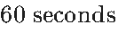, the Console requests a session restore over Stream 0. This flow uses a single-use Resume Token generated via HKDF-Expand from the active session key context:
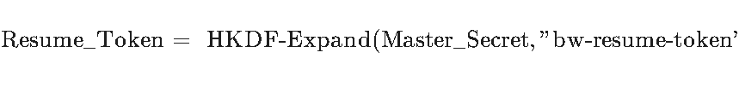

BW-RFC-017: True Zero-Allocation Memory Engine
To eliminate heap fragmentation and allocator lock contention under high-FPS media loops, memory resources must be pooled statically on startup. The platform establishes five core pools:
- FramePool: 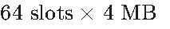 (handles uncompressed 4K video frames).
- PacketPool:  (handles network MTU serialization).
- TexturePool: 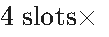 physical VRAM textures (for DXGI/SCK hardware pointers).
- AudioPool: 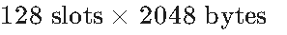 (stages PCM loopback capture).
- ClipboardPool: 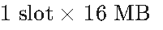 (encapsulates synchronized payload blocks).

BW-RFC-018: Encoder State Machine
The hardware-accelerated encoding pipeline progresses through a strict local runtime sequence:
[IDLE] ──► [WAIT_FRAME] ──► [COLOR_CONVERT (GPU)] ──► [ENCODE (MFT/VAAPI)] ──► [NET_QUEUE]
▲ │
└─────────────────────────────── [COMPLETE] ◄──────────────────────────────────────┘
If the pipeline experiences a driver timeout or hardware error during COLOR_CONVERT or ENCODE, the state machine falls back to software encoding (OpenH264), flushes the active TexturePool pointers, and flags error code BW-4000.

BW-RFC-019: Advanced Input Abstraction & Repetition Policy
- Keyboard Repeat Handling: To prevent network packet floods when a user holds down a key, the Console executes localized repeat compression. It transmits the initial KeyDown event, and subsequently only dispatches periodic keep-alive sync packets if the repeat interval is held.
- Unicode & Dead-Key Processing: Keyboard input events transmit raw OS virtual-key codes alongside their resolved UTF-8 Unicode representations. Dead keys (e.g., diacritics) are buffered on the Console side and transmitted as unified, fully-composed Unicode sequences to prevent target OS translation mismatches.

BW-RFC-020: Enterprise Identity Integration (SAML, OIDC & LDAP)
- Federated Auth Path: For enterprise environments, the OPAQUE PAKE is replaced by a federated OAuth 2.0 / OpenID Connect (OIDC) flow.
- Authentication Sequence:
  - The Console operator authenticates against the enterprise Identity Provider (IdP) (e.g., Okta, Azure AD) via a secure browser loop.
  - The IdP returns an authorized JWT.
  - The Console presents this JWT to the Blackwing Control Plane via RequestSessionToken.
  - The Control Plane validates the JWT claims, queries active LDAP/Active Directory group policies, and issues a cryptographically signed JWS authorizing the session on the target Agent.

BW-RFC-021: Geographic Relay Selection & Scaling
- Relay Discovery: When a session is authorized, the Control Plane selects the optimal Relay node based on a weighted multi-dimensional heuristic:
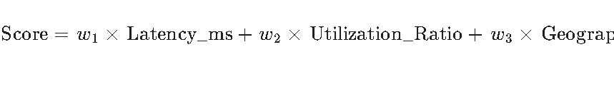
- Failover Policy: If a Relay experiences a sudden RTT spike (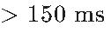) or active network packet drops (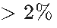), SRE automated DNS policies (Anycast coupled with health probes) route subsequent handshakes to the next lowest-cost regional Relay.

BW-RFC-022: Multi-GPU Selection Framework
To handle target machines with complex GPU topologies (e.g., Intel iGPU + NVIDIA dGPU + virtual headless displays):
- Topological Discovery: On startup, the bw-capture module queries DXGI and Vulkan physical device registries.
- Selection Policy: The capture engine prefers the discrete GPU (dGPU) hosting the display context currently bound to the active user's desktop compositing window. If the target system is virtualized or headless, the agent spawns an artificial Vulkan swapchain context on the headless virtual GPU, falling back to software rasterization only as an emergency safety.

BW-RFC-023: Adaptive Compression Policy
Data streams are dynamically compressed based on bandwidth availability and resource constraints:
Stream / Channel | Target Payload Type | Compression Algorithm | Pacing / Priority Class
Stream 5 (Clipboard) | Rich Text, Images, XML | LZ4 (Fast compression) | Synchronization
Stream 6 (File Transfer) | Arbitrary binaries | Zstd (High compression ratio) | Bulk (Max 25% link cap)
Stream 9 (USB) | Raw USB descriptor packets | None (Raw bypass) | Bulk

BW-RFC-024: Process Supervision & Crash Recovery
The Blackwing Service runs as a highly privileged background daemon (SYSTEM/root) and acts as the master supervisor for the unprivileged Session Runner process.
- Crash Detection: If the Session Runner crashes (e.g., due to segmentation fault or unhandled panic), the supervisor captures the process exit code.
- Supervised Recovery Sequence:
  - The supervisor allocates a new Session Epoch.
  - It respawns the Session Runner in the user's graphical context.
  - The Runner establishes a fast resume handoff with the active Console using cached state credentials.
  - The Console user experiences a temporary 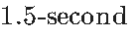 frame freeze during reconstruction, bypassing the need to re-authenticate manually.

BW-RFC-025: Enterprise Compliance & Audit Integrity
- Compliance Hardening: To align with SOC 2 Type II and ISO 27001 requirements, all security-sensitive events are signed using the Agent's identity key before being piped off-host.
- Log Tamper Detection: Every audit log payload contains the hash of the immediately preceding log block, constructing a cryptographically chained ledger of historical operations that cannot be altered locally without triggering immediate validation alarms.

2. Structured Prometheus Metric Registry
Blackwing endpoints and Cloud plane components expose a standardized Prometheus metric scrape endpoint (/metrics) running on port 9090 (restricted to secure local internal polling networks):
Metric Name | Type | Labels | Description / SLA Warning Threshold
blackwing_frame_latency_us | Histogram | component, resolution | End-to-end capture and processing latency. Warning if .
blackwing_encode_latency_us | Histogram | codec, gpu_device | Hardware encoder execution duration. Warning if .
blackwing_quic_rtt_us | Gauge | session_epoch, peer_ip | Direct transport round-trip time. Warning if value .
blackwing_relay_sessions | Gauge | relay_node_id, tenant | Total concurrent active sessions routed through a specific Relay node.
blackwing_packet_drop_ratio | Counter | stream_id, direction | Ratio of lost to transmitted QUIC packets on unreliable datagram channels.
blackwing_pool_exhaustion_total | Counter | pool_name | Number of times a static memory pool checkout was rejected. SRE Alert.

